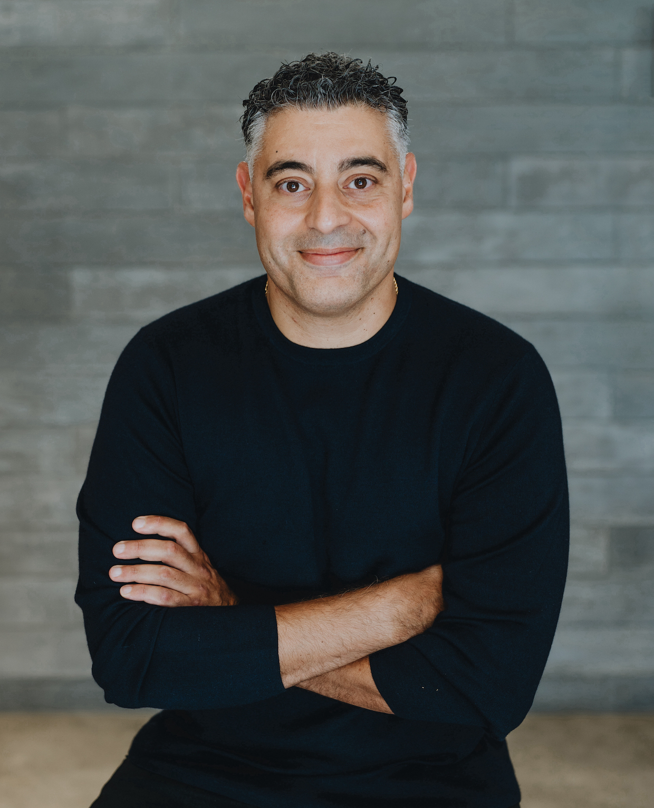

Kareem Saleh
Co-founder and CEO
LinkedIn | FairPlay.ai

Kareem Saleh is the co-founder and CEO of FairPlay AI, the world's first fairness-as-a-service company. Financial institutions use FairPlay’s AI-powered tools to assess their automated decisioning models in minutes to increase both fairness and profits. Kareem founded FairPlay in 2020 after spending his career improving consumer lending to historically disadvantaged groups. As the son of Egyptian immigrants, Kareem saw firsthand how his parents' denial of a small business loan made it harder to achieve the American dream for his family.

Previously Kareem served as Executive Vice President at Zest.ai, where he led business development for the company’s machine learning-powered underwriting platform. Kareem also served as an executive at SoftCard, a mobile payments company acquired by Google. Before joining startup ranks, Kareem served in the Obama Administration, first as Chief of Staff to the State Department’s Special Envoy for Climate Change, where he helped manage the 50-person team that negotiated the Paris Climate Agreement, and later as Senior Advisor to the CEO of the Overseas Private Investment Corporation (OPIC), where he helped direct the U.S. Government’s $30B portfolio of emerging market investments with responsibility for transaction teams in Europe, Latin America and the Middle East. Kareem also served as an attorney.

Kareem is a Forbes contributor and a frequent speaker on AI, fair lending and algorithmic bias. Prior speaking events include Money 20/20, the Fintech Nexus Conference, and Fintech Meetup. He has testified before Congress about AI and the adverse impacts of algorithmic bias.

Kareem is a graduate of Georgetown University Law Center and an honors graduate of the University of Chicago. He resides in Los Angeles with his partner, Melissa, and their two toddler daughters. In his spare time, he enjoys practicing the breathing techniques taught by Wim Hof, a Dutch extreme athlete noted for his ability to withstand low temperatures.

